SUMMARY: The MC Waterways Transformation Team (“Team,” aka “Committee”) has been tasked with rehabilitating the HOA waterways and adjacent embankments, improving year-round water flows, and ensuring that our HOA-owned trees and bridges have integrity to last at least another 50 years with appropriate ongoing maintenance. See MC HOA Water Ways Transformation Team Charter for further details.
BACKGROUND: Meadow Creek Subdivisions No. 1 and No. 2 (aka Wolfram Subs 1 & 2, or “HOA”) is a hidden gem located in Garden City. The ponds and embankments are the centerpiece of the development and the most significant source of its value. However, the privilege of living in Meadow Creek comes at a cost. Current and past HOA assessments have not been sufficient to support the necessary reinvestment in routine maintenance of our waterways, embankments, and shade canopy. The condition of these assets will continue to decline unless we take committed action now to restore the condition and long-run sustainability of these assets.
The HOA has not performed any significant pond maintenance since the inception of the subdivision in 1992, and now the bill is due. This underinvestment was first recognized in 2007, when costs to dredge the ponds were $30/Cubic Yard. Costs are now estimated (2022) to be in the $55-65/Cubic Yard range. During that same time period, the estimated volume of sediment and organic material needing to be dredged (i.e., “sludge”) increased 10-fold (from 1,150 to 12,700 cubic yards). The degradation is getting worse year-by-year. Similarly, the HOA-owned shade trees planted along the HOA ponds have not been routinely pruned and maintained. Many tree species originally planted are 30-year trees and are now at end-of-life. The HOA ponds and trees require a major rehabilitation to ensure the long-term health, aesthetics, and sustainability of these assets for at least the next 50 years.
APPROACH: The Team recommends an integrated and holistic approach to the project, aiming to “get-in and get-out” of these environmentally sensitive habitat areas with minimal re-visits and re-work. This approach will minimize the physical impact on the ecosystems and the inconvenience and disturbance of Lot Owners adjacent to the ponds. Dredging activity would be phased over a three-year period and would occur during the winter months January through March. The scope of work for each pond will include dredging, dead tree removal, tree pruning and replacement, bank re-vegetation, bank enforcement and bridge repair or replacement. See MC HOA Waterways Transformation Team Project Narrative for scope details.
OBJECTIVES:
Phase 1 (2024) will be a pilot project for proof-of-concept and will include the area in Pond 2 west of N. Lake Shore Dr. up to the foot-bridge. This area was chosen because of easy access for equipment and debris haul-out on HOA property and will be visible by residents for observation during the project. The method of dredging this area will be to de-water (pump water out downstream), remove sludge (organic decaying matter), debris and dead trees with mechanical excavation equipment, and disposal by hauling off in dump trucks. The objective of the pilot project is to remove approximately 1440 cubic yards of sludge (102 dump truck loads) and increase the water depth by 1 to 3 feet. The pilot project will also provide a realistic, sample-size scope of work, and costs which will inform the budgets for Phase 2 and Phase 3. See Attachment 1 – Pond Layout and overall Sludge Volume Estimates.
Phase 2 (2025) will include the remainder of Pond 2 and all of Pond 3. Pond 3 is the waterway east of N Lakeshore Dr. The objective of Phase 2 to remove approximately 5250 cubic yards of sludge (375 dump truck loads) and increase the water depth by 2 to 3 feet.
Phase 3 (2026) will include Ponds 1, 4, and 5. Pond 4 is the 2-acre pond North of the clubhouse. Dredging in Pond 4 will occur at the east and west ends. Ponds 1 and 5 are located on the west side of the HOA separating Meadow Creek from Silver Wood HOA. The costs for Ponds 1 & 5 would be shared with Silverwood, as those ponds are within the Silverwood HOA boundary. The method of dredging these areas will be a combination of de-watering and mechanical excavation, and the use of a portable suction dredge and geo-tubes for dewatering the sludge.
COST & SCHEDULE: The Team believes it can complete the 3-phase project can be completed within 24-30 months for a cost of $1 Million - $2.5 Million ($5,000-$12,000 per Lot) depending upon approved project scope. The Team and the Board investigated the possibility of grants, and financing options, as alternatives to one or more special assessments on Owners for the entire project cost. No grants were identified. No viable financing options were identified, as the HOA has few assets and no proven ability to service debt except by means of levying special investments. The most likely financing method will be a series of sequential special assessments over the 2023-2025 time period corresponding to the cost of each phase of the project. Field activities will commence late-Fall 2023 and continue through Late-Spring 2025. See Cost Summary table below.
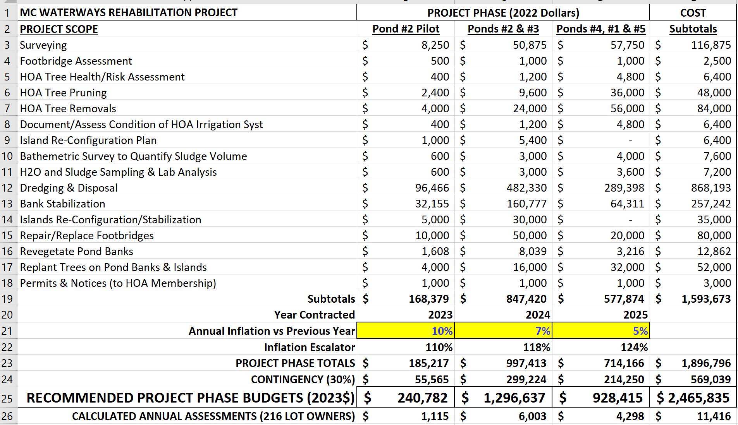
COMMUNICATIONS: The success of a project of this scale will require a high level of buy-in and support from the MC HOA Members, MC Board, Silverwood HOA and local Fire, Police and Public Works (i.e., trash pickup) and other stakeholders. Up to 1,000 truckloads of sludge will need to be hauled away, necessitating the temporary closure of some streets within the development, and creating congestion on nearby arterials. The cost of the project, done right, will be significant, and require increased assessments on all Lot Owners. New trees and re-landscaping will take several or many years to mature and may look awkward for several seasons. All of these issues can either fester in silence or be surfaced and discussed openly. The Team recommends open dialogue. The communications timeline proposed by the Team is as follows: 1) Finalize Work Scope & Budget, 2) Obtain feedback and steer from the HOA Board, 3) Present the Plan/Budget in a general session open to all Owners, 4) Integrate Owner feedback and make formal proposal to Board.
CONCLUSION: Rehabilitation of the MC waterways and embankments is a large undertaking, but an investment worth making. Years of under-investment in pond and tree maintenance now leave the HOA with a choice between continual degradation and decline, or transformation and renewal. The project Team recommends an integrated and holistic approach, taking up to 24-30 months and $1 Million - $2.5 Million, to address all the pond-related assets including embankments, footbridges, and islands. The outcome will be a sustainable waterway and embankment ecosystem that will be viable for the next 50 years with appropriate annual maintenance and stewardship.

ATTACHMENT 1 – Pond Layout and Sludge Estimates
